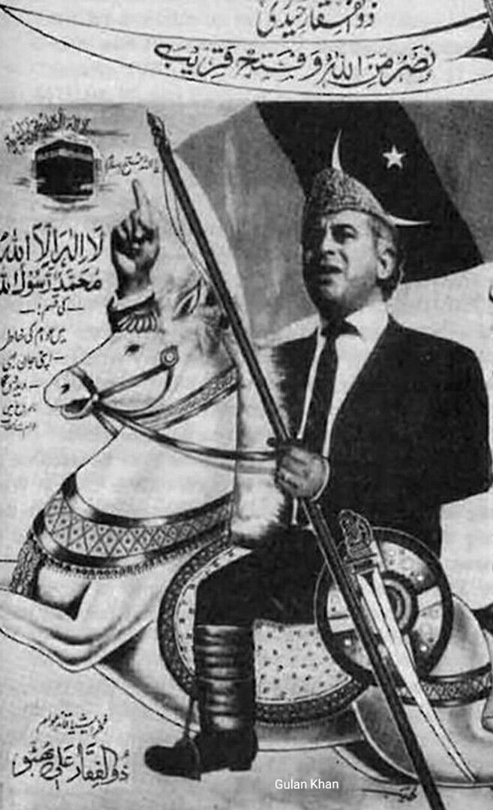Observe, inference, and questions from the picture.

**People:**

* Zulfiqar Ali Bhutto (Head of PPP).

**Objects:**

* Horse, sword and shield, Ka’bah, Kalma, a dua for victory, present day flag of Pakistan People’s Party, three-piece suit and tie, and Quid e Azam topi.

**Activities:**

* Pointing to the sky, telling his supporters to move forward, riding a horse, leading a movement for PPP, Islamic ideologies to be implemented, sacrifice for the country.

**Inference:**

* The Pakistan People’s Party, a communist party of Bhutto which was initially formed on the basis of communism was extremely influenced by the culture presented by General Ayub Khan, who copied the way of Quaid e Azam that in order to rule a country that its leader must look physically good so that he would look like a strong political personality in front of the people to whom people can rely upon.
* At the time of Bhutto’s reign, the Arab peninsula had newly discovered oil, and selling it in dollars was very profitable for the Arabs, who now began to show off their wealth by extravagance but also began to loan other Muslim third world countries money. In return for that money, and beings the country with Holy cities of Makkah and Madina, whatever the Saudi Arabian king said, was done by other countries. So Bhutto was leading a movement against the US to oppose them and forming an alliance with Muslim countries to sell oil in Muslims countries currency instead of US Dollars.
* Zulfiqar Ali Bhutto’s socialist ideas were not acceptable by Jamate Islami (JI)’s dominant leader Moulana Moududi and his supporters. So they were opposing his new open-minded policies and saying that the foundations of Islam were weak due to which Pakistan got separated. The rise of JI’s leader voice was a threat to the PPP’s vote bank because using the slogan of Islam against any party was a major tactic. Hence things related to Islam were also portrayed in this poster of elections.
* **The questions that raise to my mind are:**

1. Bhutto’s relations with the US were good, but still, he opposed the US. When there was an Islamic population demanding more Islamic laws, why did he oppose international powers like the US instead of focusing on internal affairs?
2. If Bhutto was insisted on making a Muslim bloc so that oil could be sold in the Muslim countries' currency, why was he towards a more open-minded Islamic society? Was he trying to make good relations with USSR since it was a superpower and the cold war was going on or wanted to eventually sell oil in PKR?

These links have the answer to the questions.

<https://www.dawn.com/news/1195863>

<https://www.dawn.com/news/1197368>

<https://nayadaur.tv/2018/07/the-religious-vote-in-pakistan/>